BALANCING CEILING AND TASK LIGHTING UNDER VARIABLE DAYLIGHT AND OCCUPANCY: A SIMULATION-BASED OPTIMIZATION STUDY

Kefan Chen^{1,}*, Guanli Feng², Yu Qian Ang¹, Adrian Chong¹

¹College of Design and Engineering, National University of Singapore, Singapore.
²Department of Architecture, National University of Singapore, Singapore

ABSTRACT
Office lighting is often designed for full occupancy, although workplace use varies in occupant number and location. This mismatch can illuminate unoccupied areas or workstations already served by daylight. We evaluated a Balanced Light Control Framework that coordinates three ceiling-light zones and 24 workstation task lights while meeting visual-comfort requirements. A Singapore office laboratory was simulated under Clear, Overcast, and Night conditions for 1–15 occupants. Five matched seating layouts at each occupancy count yielded 225 scenarios. A penalty-based genetic algorithm (GA) searched for low-power feasible settings, which were compared with zonal PIR ceiling-only control and rule-based hybrid control. Relative to zonal PIR, optimized hybrid control reduced mean lighting power by 76.9% under Clear, 62.0% under Overcast, and 46.8% at Night. Relative to rule-based hybrid control, it reduced mean power by 22.5% under Overcast and 25.0% at Night, but was 6.7% higher under Clear. The retained configurations shifted from task-light-only operation under Clear to increasing ceiling-light contributions under Overcast and Night. Seating layout also changed power at fixed occupancy counts. Coordinating ceiling and task lighting therefore offered substantial power-reduction potential, while the achievable reduction depended on daylight and seating layout.

KEYWORDS
Occupancy-responsive lighting control, Ceiling and task lighting, Daylight-responsive control, Lighting-power optimization, Visual comfort

INTRODUCTION
Office lighting is commonly designed for full occupancy, while actual use varies across time and workstations. Schedule-based or count-based controls can therefore illuminate unoccupied areas or workstations already served by daylight. Room-level data confirm substantial occupancy variability (Tekler et al. 2022). Effective control must respond to both occupant number and location.
Ceiling lighting and task lighting operate at different spatial scales. Ceiling luminaires provide background illumination and uniformity, whereas task lights deliver light directly to individual workplanes and allow local adjustment (De Korte et al. 2015). High-resolution daylight and occupancy sensing can restrict electric lighting to occupied areas (Lowcay et al. 2020), while task-light studies show the value of localized control (Papinutto et al. 2021). These systems are usually evaluated separately. Their most power-efficient coordination may change with daylight, occupancy count, and seating layout, but these factors are rarely examined together.

This study examines how ceiling and task lighting can be coordinated under variable daylight and occupancy while maintaining visual comfort. The Balanced Light Control Framework represents three ceiling-light zones and 24 task lights in a simulated open-plan office. A penalty-based genetic algorithm (GA) searches the discrete control space for low-power feasible configurations. Optimized hybrid control is compared with zonal PIR ceiling-only control and rule-based hybrid control across 225 matched sky-condition, occupancy-count, and seating-layout scenarios. The objective is to quantify achievable lighting-power reduction and identify how the ceiling–task balance changes across operating conditions.

METHODS
Optimization workflow
Figure 1 summarizes the workflow. As shown in Figure 1(a), each scenario combined the three-dimensional office model, one sky condition, and a seating layout containing 1–15 occupants. Occupancy was capped at 15 because higher counts occurred during only 0.3% of recorded time in the reference dataset (Tekler et al. 2022). Figure 1(b) shows the corresponding 27-variable control vector for three ceiling-light zones and 24 task lights.

For each candidate vector, ClimateStudio calculated illuminance and uniformity for occupied task areas and their surroundings. Figure 1(c) links these outputs to the visual-comfort constraints and lighting-power objective. The GA iterated selection, crossover, mutation, and elitism through the loop shown in Figure 1(d,e) until the lowest-fitness feasible configuration was retained. Figure 1(f) compares each retained configuration with the two rule-based controls under the same scenario.

Case-study model and lighting systems
The case study represented one open-plan office laboratory within a larger Singapore building. Figure 2 locates the simulated room within the host model; only this room was evaluated. The room contains 24 fixed workstations, each with an independently adjustable task light. Ceiling lighting is divided into three zones serving seats 0–7, 8–15, and 16–23. ClimateStudio calculated illuminance and uniformity for occupied task areas and their surroundings.
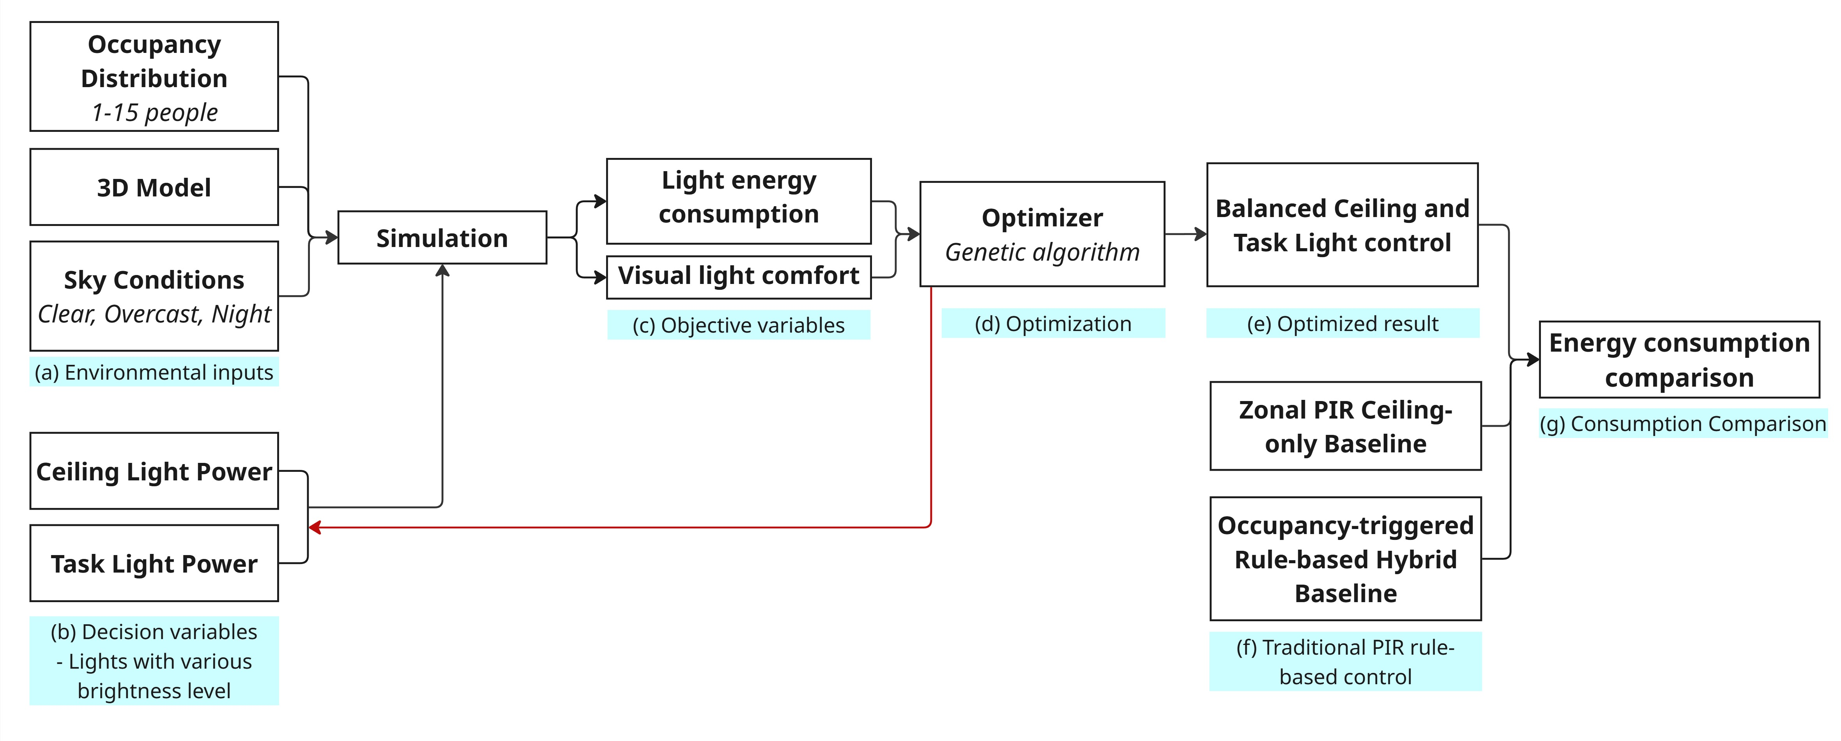
Figure 1. Workflow for evaluating the Balanced Light Control Framework

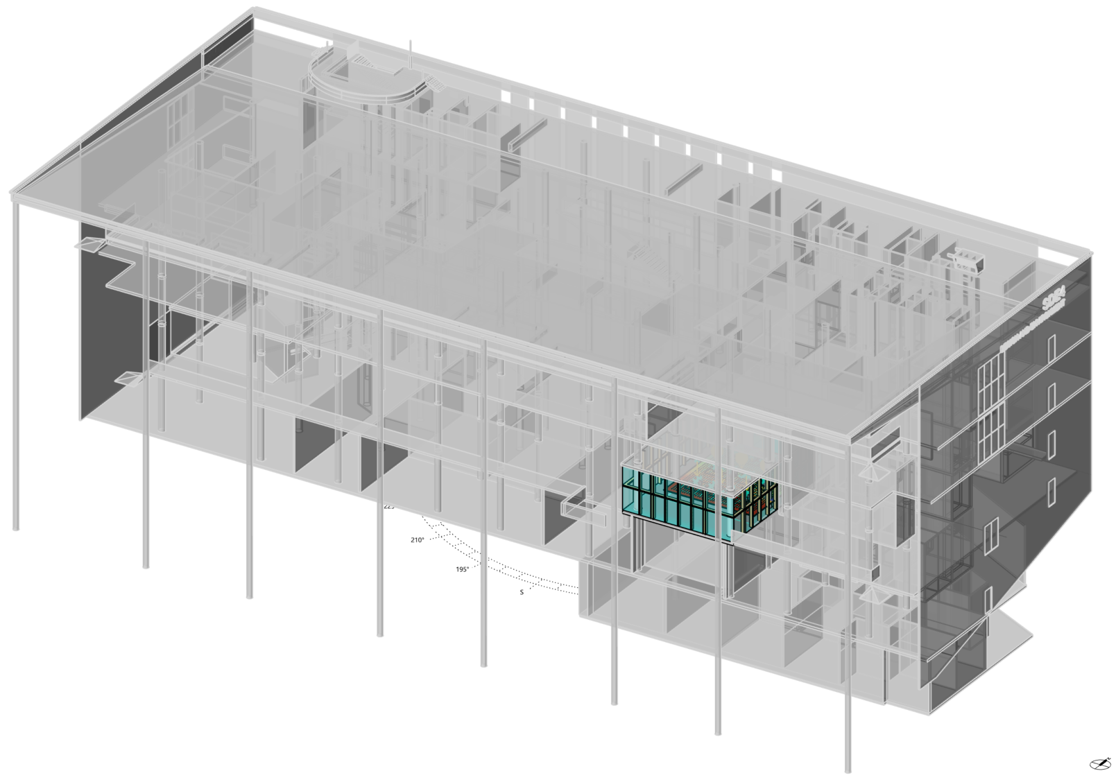
Figure 2. Location of the simulated office room within the host building

Scenario matrix
Table 1 summarizes the scenario matrix. Simulations used three sky conditions labelled Clear, Overcast, and Night. Daylight conditions were referenced to Changi International Airport, Singapore, at 13:00 on 21 March. Overcast used ‘Sky: [Changi.Intl.AP,SG,SGP CIE_Overcast 3.21.13.00]’, Clear used the corresponding clear-sky setting, and Night excluded daylight. Occupancy count ranged from 1 to 15. Five seating layouts were randomly selected at each count. The same 75 occupancy-count and seating-layout cases were evaluated under all three sky conditions, yielding 225 matched scenarios.

Table 1. Experimental scenario matrix
Factor | Levels |  | Cases
Sky condition | Clear, Overcast, Night |  | 3
Occupancy count | 1–15 occupants |  | 15
Seating layout | Five layouts per count |  | 5
Total | Matched scenario matrix |  | 225
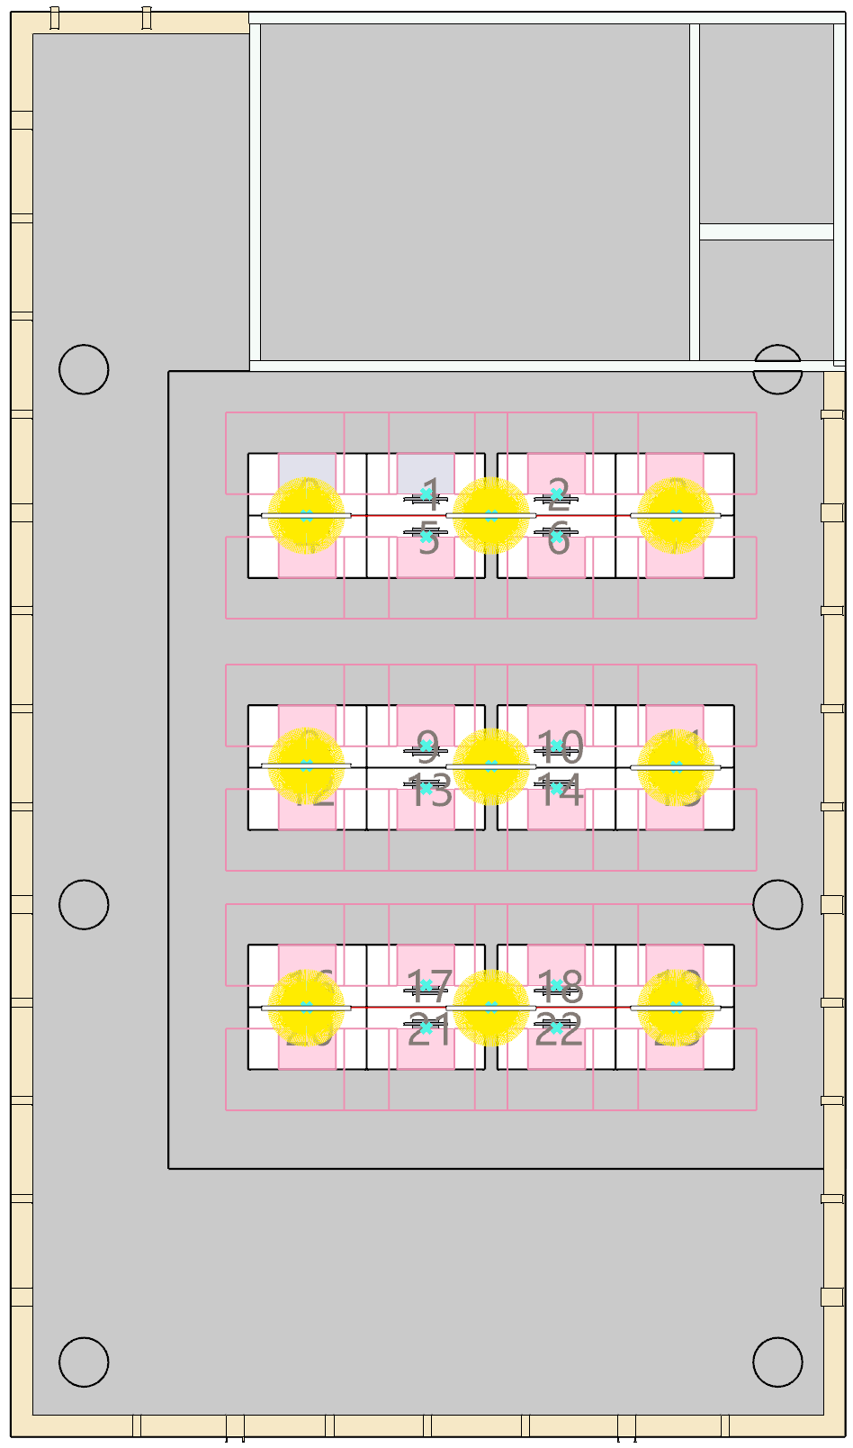 |  | 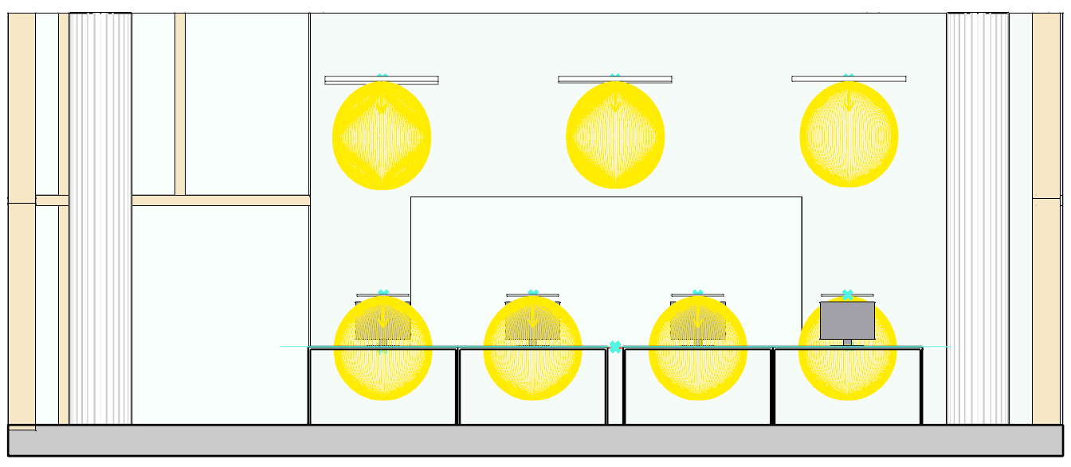
 |  | - Front View
 |  | 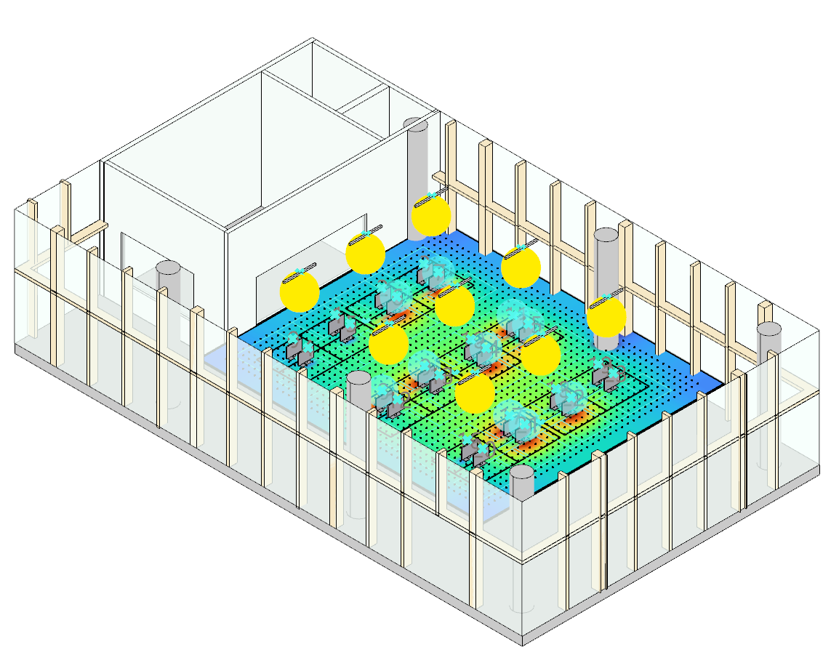
- Top View |  | - Perspective View
Figure 3. Room-scale simulation model, seating layout, ceiling-light zones, and task-light arrangement

Decision variables and lighting power
The control vector specified discrete output levels for three ceiling-light zones and 24 task lights. Task lights at unoccupied workstations remained off. Each task-light level added 1.5 W, and each ceiling-zone level added 13.2 W. Total lighting power was calculated as:

P = 13.2 Σⱼ₌₁³ Lc,j + 1.5 Σᵢ₌₁²⁴ Lt,i .

This expression reproduced the reported lighting power for all 225 retained configurations. Because the scenarios had no assigned duration, results are reported as lighting power (W), not energy (kWh).

Rule-based comparison strategies
Two deterministic controls used the same 225 occupied-seat lists. Under zonal PIR ceiling-only control, task lights remained off and empty ceiling-light zones were switched off. For each occupied zone, the ceiling-light level equalled the highest seat-specific requirement among its occupants. Rule-based hybrid control applied the same zone-level maximum to ceiling lighting and assigned a prescribed task-light level to each occupied workstation. Unoccupied task lights remained off. Both controls used exact seat locations; rule-based hybrid control therefore assumed workstation-level occupancy triggering.

Under Night, zonal PIR assigned ceiling level 13 to the two outer seat columns and level 11 to the two inner columns. Under Overcast, seat requirements were 0/3:10, 1/2:9, 4–6:8, 7:9, 8/11:8, 9/10:7, 12/15/16/19:5, 13/14/17/18:4, and 20–23:0. Under Clear, they were 0–3:6, 4–5:1, 6–7:2, 8–10:1, 11:2, and 12–23:0. Rule-based hybrid control used the ceiling/task pair (8,3) for every occupied seat under Night. Under Overcast, the pairs were 0–3:(5,4), 4–7:(4,4), 8–11:(3,3), 12–19:(0,3), and 20–23:(0,0). Under Clear, they were 0–3:(0,4), 4–11:(0,1), 12–15:(0,0), 16–19:(0,2), and 20–23:(0,0). These levels met the stated visual requirements. Baseline power used the same 13.2 W ceiling-zone and 1.5 W task-light coefficients.

Visual-comfort constraints and objective function
Visual-comfort requirements followed SS 531:2006. Occupied task areas required at least 500 lux and uniformity Emin/Eavg ≥ 0.70. Surrounding areas required at least 300 lux and uniformity ≥ 0.50. Normalized violations were added to lighting power through a quadratic penalty function:

Fitness = P + λE1(vE1)² + λE0(vE0)² + λU1(vU1)² + λU2(vU2)².

Here, v is the normalized violation of an illuminance or uniformity threshold, and λ is its penalty coefficient. Penalties prioritized visual feasibility before lighting power. [AUTHOR INPUT REQUIRED: insert penalty coefficients and the sensitivity test used to reject infeasible low-power solutions.]

Genetic-algorithm optimization
Figure 4 presents a representative seven-occupant case. It links the Galapagos optimization interface to the corresponding seating layout and simulated illuminance field.

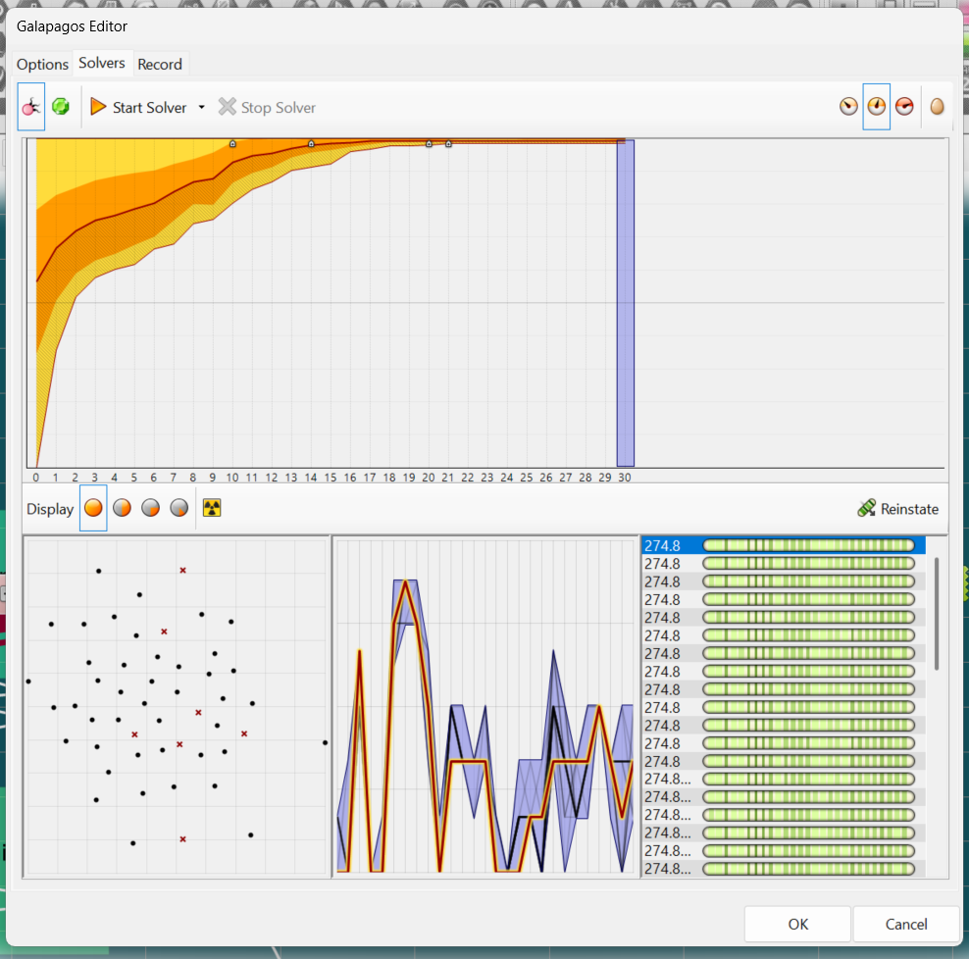 | 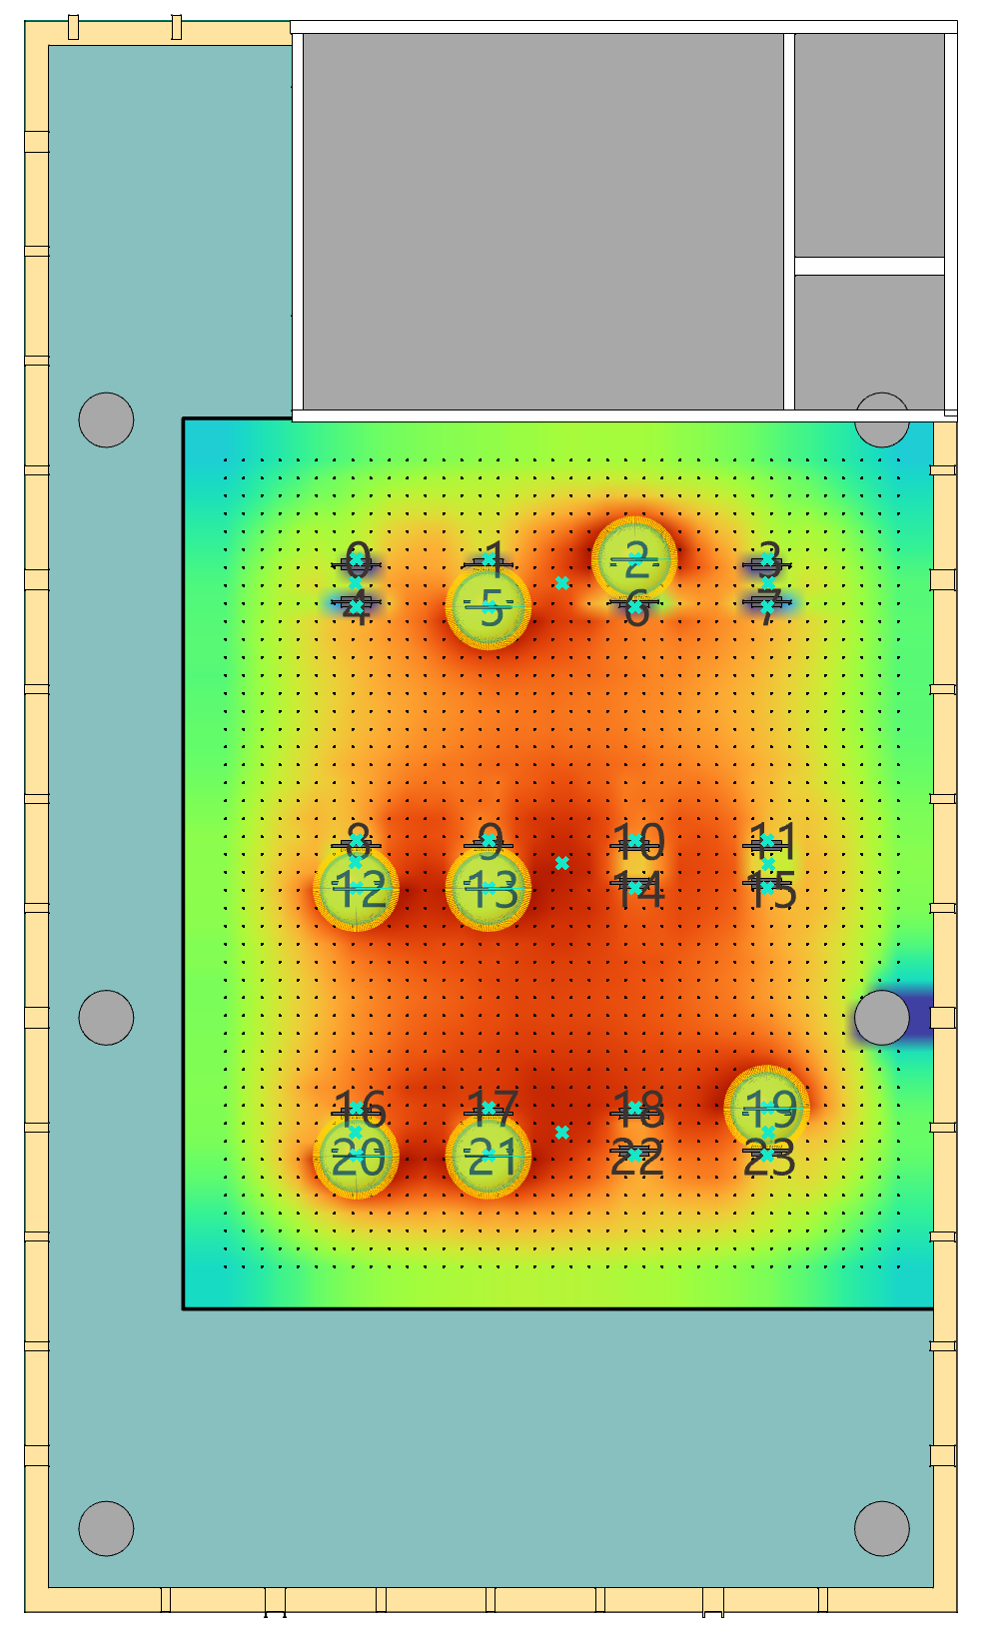
Figure 4. Representative seven-occupant optimization: (a) Galapagos interface; (b) corresponding seating layout and simulated illuminance field

Galapagos in Grasshopper operated in minimization mode. For each scenario, it searched combinations of the 27 discrete control variables. ClimateStudio and associated scripts evaluated illuminance, uniformity, and lighting power for each candidate. The retained output was the lowest-fitness configuration satisfying the encoded constraints. [AUTHOR INPUT REQUIRED: insert population size, generation limit, convergence criterion, random seed, repeated-run count, and software versions.]

RESULTS
Lighting-power reduction across sky conditions
Figure 5 shows how lighting power changed with occupancy count. Lines show the mean of five matched seating layouts; bands show their minimum–maximum range. Mean power for zonal PIR, rule-based hybrid, and optimized hybrid control was 75.50, 16.34, and 17.44 W under Clear. The corresponding means were 244.46, 120.03, and 93.01 W under Overcast, and 443.52, 314.78, and 236.10 W at Night. Relative to zonal PIR, optimized hybrid control reduced mean power by 76.9%, 62.0%, and 46.8%, respectively. Rule-based hybrid control reduced mean power by 78.4%, 50.9%, and 29.0%. Both hybrid strategies therefore reduced power across all three sky conditions, while their relative performance changed with daylight availability.
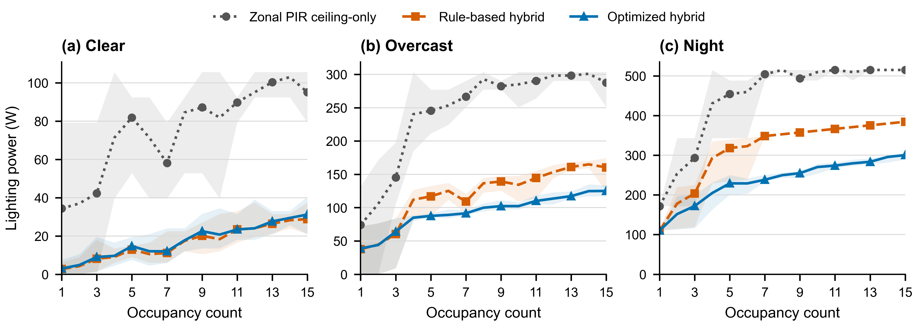
Figure 5. Lighting power versus occupancy count for zonal PIR ceiling-only control, rule-based hybrid control, and optimized hybrid control under (a) Clear, (b) Overcast, and (c) Night. Lines show the mean across five matched seating layouts; shaded bands show the observed minimum–maximum range (n = 5 layouts). Panel y-axis ranges differ.

Power allocation between ceiling and task lighting
Figure 6(a) shows how total power was divided between ceiling and task lighting. Under Clear, both hybrid strategies used no ceiling lighting; optimized hybrid control and rule-based hybrid control required 17.44 and 16.34 W of task lighting. Under Overcast, optimized hybrid control used 61.07 W of ceiling lighting and 31.94 W of task lighting, compared with 86.77 and 33.26 W for rule-based hybrid control. At Night, the corresponding values were 194.48 and 41.62 W for optimized hybrid control, and 278.78 and 36.00 W for rule-based hybrid control. The lower optimized total under Overcast and Night therefore came mainly from reduced ceiling lighting.

Figure 6(b) compares mean reductions relative to the rule-based controls. Optimized hybrid control used 6.7% more power than rule-based hybrid control under Clear, but 22.5% less under Overcast and 25.0% less at Night. It used less power in 7/75, 60/75, and 69/75 matched cases, respectively. The result shows that a simple task-light rule was effective under Clear, whereas the larger ceiling–task search space offered additional reductions under Overcast and Night.
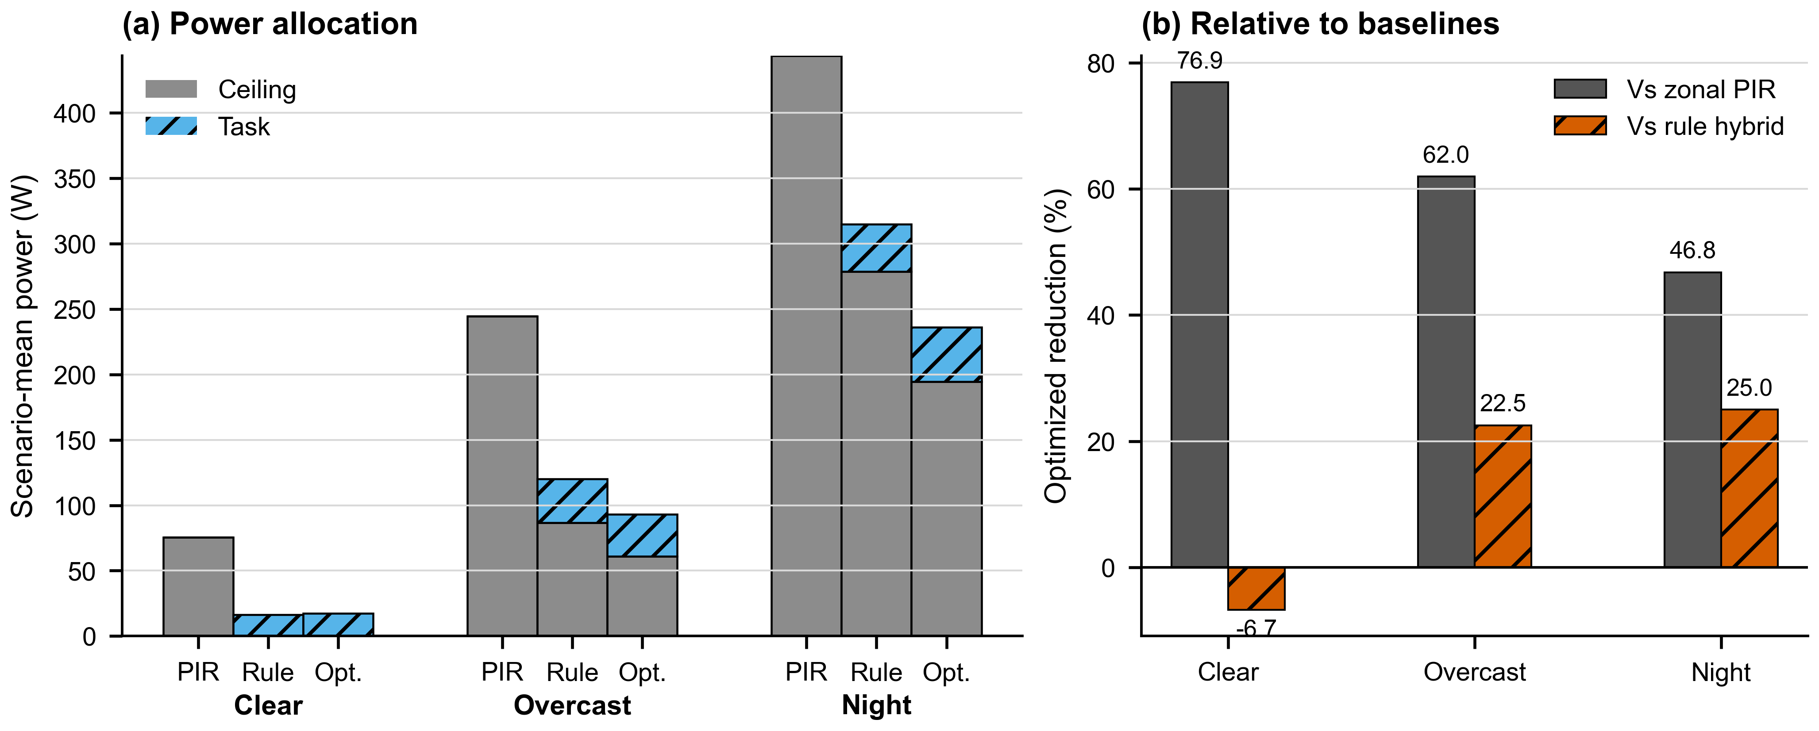
Figure 6. Power allocation and comparative reduction across sky conditions. (a) Mean ceiling- and task-light power across 75 matched occupancy-count and seating-layout cases. (b) Mean power reduction of optimized hybrid control relative to zonal PIR ceiling-only control and rule-based hybrid control; negative values indicate higher optimized power.

Effects of occupancy count and seating layout
Optimized hybrid power generally increased with occupancy count, from 3.0 to 31.2 W under Clear, 38.8 to 125.1 W under Overcast, and 110.1 to 300.4 W at Night. The trajectories were not monotonic because seating layouts activated different ceiling-light zones and received different daylight. At a fixed occupancy count, the mean minimum–maximum range across five layouts was 14.6 W under Clear, 24.8 W under Overcast, and 31.4 W at Night. The corresponding ranges were 44.9, 59.8, and 60.7 W for zonal PIR, and 12.5, 38.9, and 35.2 W for rule-based hybrid control. Seating layout therefore influenced every strategy, and occupancy count alone did not determine lighting power.

DISCUSSION
Comparison across the three sky conditions shows that coordinated ceiling and task lighting can reduce power under different levels of daylight availability. Under Clear, daylight supplied the background illumination and both hybrid strategies relied on task lighting. Under Overcast and Night, ceiling lighting became necessary, and the retained configurations used localized task lighting to limit ceiling demand. The framework therefore exposes how the power-efficient ceiling–task balance changes with sky condition.

Comparison with rule-based hybrid control separates the benefit of coordinating two lighting layers from the additional benefit of optimization. Rule-based hybrid control was slightly lower under Clear, where both strategies kept ceiling lighting off. Optimized hybrid control was lower under Overcast and Night, where ceiling and task levels had to be allocated jointly. This result supports sky-condition-responsive settings rather than one control rule for every daylight condition.

Seating-layout effects also have a direct sensing implication. A controller based only on occupancy count would assign identical settings to spatially different cases, although zone activation and daylight exposure changed power substantially. Practical implementation therefore requires at least zonal location information and may benefit from workstation-level sensing. The simulated controls used exact occupied-seat IDs; conventional zone-level PIR sensing would provide less spatial detail.
The study represents one office geometry, three static sky conditions, and five seating layouts per occupancy count. Results describe simulated lighting power rather than annual energy and do not include perceived comfort, sensing uncertainty, control delay, or hardware dynamics. These factors require separate validation before implementation.

CONCLUSION AND IMPLICATIONS
Across 225 matched scenarios, the Balanced Light Control Framework quantified the power-reduction potential of coordinating three ceiling-light zones and 24 task lights. Compared with zonal PIR ceiling-only control, optimized hybrid control reduced mean lighting power by 76.9% under Clear, 62.0% under Overcast, and 46.8% at Night. Rule-based hybrid control achieved reductions of 78.4%, 50.9%, and 29.0%, confirming that coordinated ceiling and task lighting reduced power under all three sky conditions.
Daylight changed both the required ceiling–task balance and the value of searching beyond fixed rules. Rule-based hybrid control was 6.7% lower under Clear, while optimized hybrid control was 22.5% lower under Overcast and 25.0% lower at Night. Seating layout also affected power at the same occupancy count. For the studied office, effective control should therefore account for sky condition and seating layout, not occupancy count alone. These findings concern simulated lighting power; annual energy and implementation performance require separate evaluation.

REFERENCES
De Korte EM, Spiekman M, Hoes-van Oeffelen L, Van Der Zande B, Vissenberg G, Huiskes G, and Kuijt-Evers LFM. 2015. Personal environmental control: Effects of pre-set conditions for heating and lighting on personal settings, task performance and comfort experience. Building and Environment 86: 166–176. https://doi.org/10.1016/j.buildenv.2015.01.002.
Lowcay D, Gunay HB, and O’Brien W. 2020. Simulating energy savings potential with high-resolution daylight and occupancy sensing in open-plan offices. Journal of Building Performance Simulation 13(5): 606–619. https://doi.org/10.1080/19401493.2020.1807604.
Papinutto M, Colombo M, Golsouzidou M, Reutter K, Lalanne D, and Nembrini J. 2021. Towards the integration of personal task-lighting in an optimised balance between electric lighting and daylighting: A user-centred study of emotion, visual comfort, interaction and form-factor of task lights. Journal of Physics: Conference Series 2042: 012115. https://doi.org/10.1088/1742-6596/2042/1/012115.
Singapore Standards Council. 2006. SS 531:2006 Code of Practice for Lighting of Work Places, Part 1: Indoor Lighting. Singapore: SPRING Singapore.
Tekler ZD, Ono E, Peng Y, Zhan S, Lasternas B, and Chong A. 2022. ROBOD, room-level occupancy and building operation dataset. Building Simulation 15: 2127–2137. https://doi.org/10.1007/s12273-022-0925-9.

* Corresponding author email: E1583443@u.nus.edu

